1 whois cisco.com
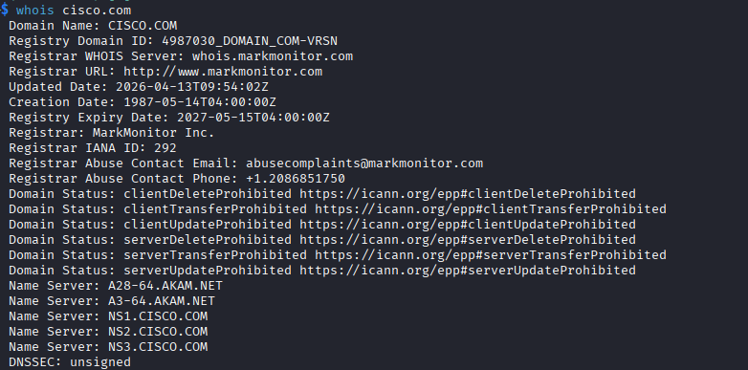

2 whois cisco.com | grep -i "registrar"
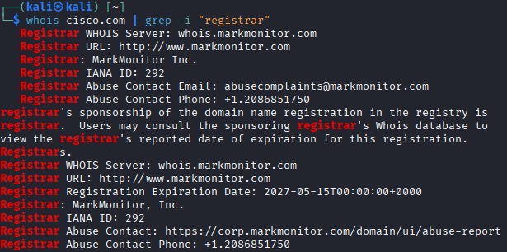
3 whois cisco.com | grep -i "date"
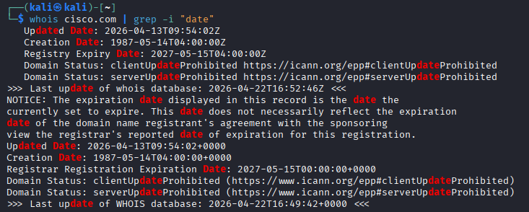
4 whois cisco.com | grep -i "registrant"
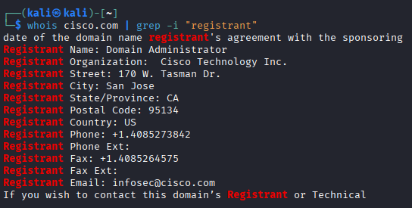
5 dig cisco.com
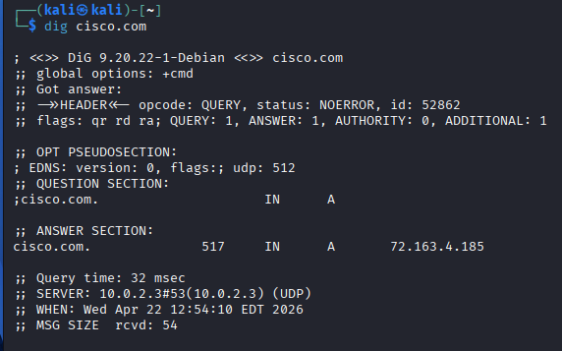
6 dig res.cisco.com TXT | grep -i "v=spf"
7 dig cisco.com MX | grep "MX"
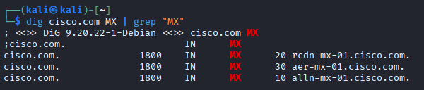
8 dig cisco.com NS | grep "NS"
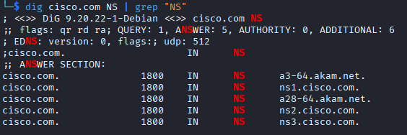
9 host cisco.com
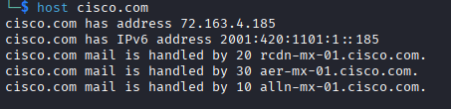
10 host -t ns cisco.com
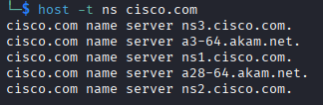
11 host -t mx cisco.com
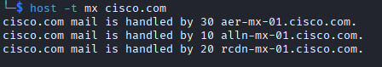
12 dnsrecon -d cisco.com
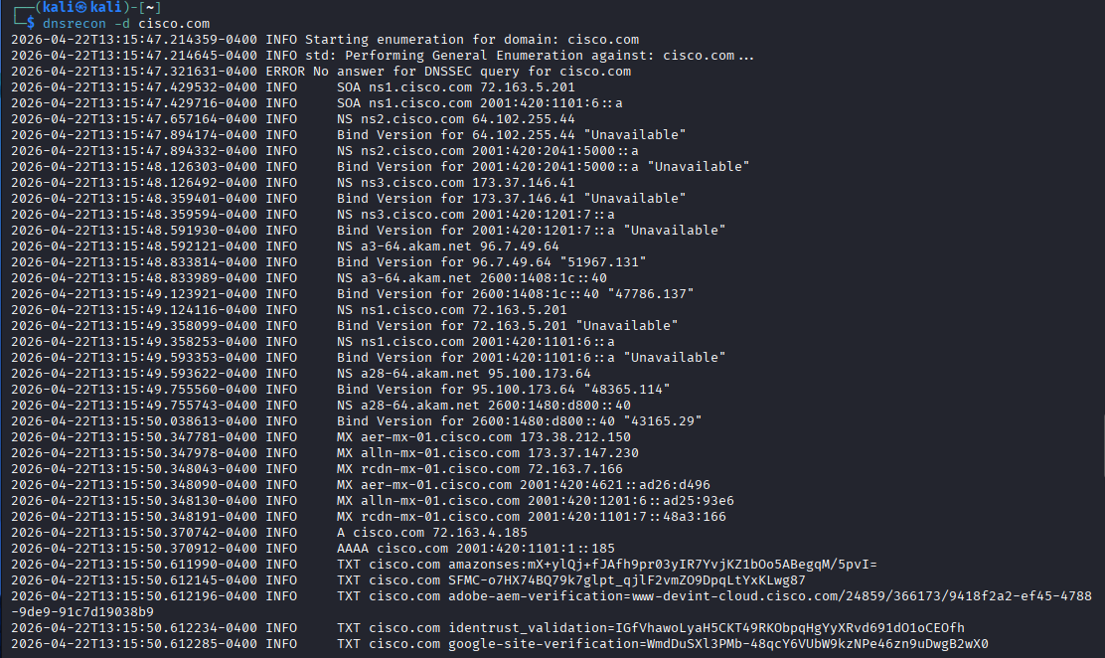
13 dnsrecon -d cisco.com 2>&1 | grep "A cisco"
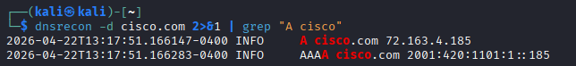
14 https://crt.sh/?q=cisco.com
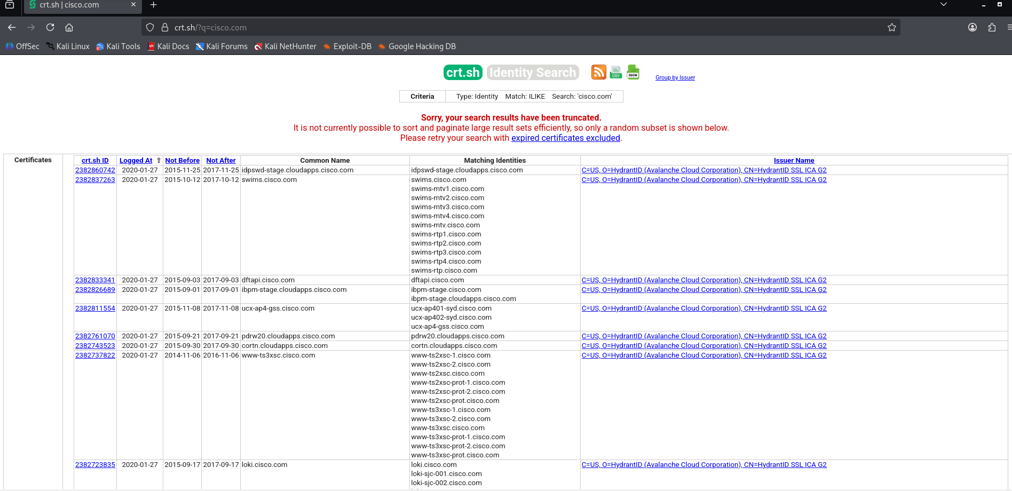
15
